Chapter 7 – Formation of rocks

1. Structure of the Earth

The illustrations below suggest two totally different Earths. If approached from space, we could image Earth as mostly land or mostly water, depending on what was facing us. The illustrations on the left suggest that the Earth is 70% land and 30% water, while that on the right suggests it is at least 70% water!

The Earth actually has a surface area of about 508 million km², of which 360 million km² (about 71%) the hydrosphere, is water. The other 148 million km² is land. About 97% of the Earth’s water is salt water in the oceans and seas. The other 3% is fresh water, of which about 77% is stored as ice at the poles, another 22% is absorbed into the ground, and only 1% is fresh water in lakes and rivers and moisture in soil and the air.

From observations of drill holes, earthquakes and volcanoes, scientists conclude that the Earth is not a solid sphere, but has several layers. (Note that resources vary significantly in their estimates of the thickness of these layers.)

- The crust, averaging only 15km thick (ranging from about 6km under the ocean depths to about 70km under continents) has been likened to the skin of an apple. The crust makes up only about 1.5% of the Earth and it is thickest under continents and thinnest under oceans. Its average density is 2.9 g/cm³ and its temperature varies from 20ºC at the surface to about 500º near the mantle. The crust and the upper, almost solid portion of the 2900km thick mantle together make up the lithosphere – the outer, solid layer of the Earth. The lithosphere averages about 70km thick.

- Under the lithosphere is the asthenosphere, ranging from 100 to 200km thick under the continents. The asthenosphere is a zone in which 1% to 2% of the rock is molten, and it acts as a low friction zone on which the lithosphere floats and moves.

- The mantle, about 82% of the Earth, varies in texture from the near solid rock in the lower lithosphere to the hot, almost fluid or `plastic’ rock in the asthenosphere, to the molten rock near the core. Its average density is 3.6 g/cm³. The molten material from volcanoes comes from the mantle. The temperature of the mantle varies between 500ºC and 3000ºC.

- Deeper inside the Earth is the 2300km thick outer core – hot, permanently molten material at temperatures between 3000ºC and 4000ºC . The core (outer and inner) is thought to be composed mainly of the metals iron and nickel and is about 7000km in diameter,. Its average density is about 6 g/cm³. The inner core, density 9.5 g/cm³ despite its 5000ºC temperature, is thought to be kept solid by the enormous gravitational pressure from the material above it.

- Complete the table using the information from this section.

Layer | Thickness range (km) | Temperature  (ºC) | Composition | Density (g/cm)
Crust
Lithosphere
Asthenoshphere
Mantle
Outer core
Inner core

1 A. Building blocks of rocks

- Elements are the simplest forms of matter. There are two major groups: metals and non-metals. Elements rarely occur in a pure state in the Earth’s crust. Most occur linked with other elements in the form of compounds.

Minerals are chemicals (elements or compounds) that occur naturally in the Earth’s crust. They are the basic building blocks of rocks. All rocks are made out of one or more minerals physically mixed and cemented or fused together.

Being chemical elements or compounds, each mineral has its own characteristic properties such as colour, crystal shape and other physical and che3mical properties that can be used to distinguish it from other minerals. While the mineral crystals that make up rocks are usually quite small, if they crystallise by themselves in cavities in rocks, they form astonishingly beautiful forms.

If we look at rocks closely, we can see the different minerals in them, particularly if we use a magnifying glass.

- Properties of minerals

Read the passage below, then answer the questions that follow
Because there are so many different minerals, we need a system to classify and identify them. Using one property is of little use because many minerals will have that property. We therefore need to consider several properties such as colour, crystal shape, cleavage, streak, hardness and lustre. While each is unreliable by itself, when used together, these properties can distinguish between minerals.

Minerals are chemical compounds or elements, so they each have a distinctive crystal shape which is characteristic of that chemical. If the crystals have formed slowly, then they will be large and easily identifiable. However, most minerals are small, crushed and distorted by pressures within the Earth’s crust and we often need a magnifying glass to see them.

Geologicsts also use the way some minerals break when they are hit to help identify them. This is called the cleavage of the mineral and occurs because of their internal structure. Mica cleaves into flat sheets and galena cleaves into cubes.

The lustre of a mineral describes the appearance of the surface of its crystals. A mineral can be among other terms, shiny, silky, pearly, vitreous, dull or metallic in appearance.

Streak is the colour of the mineral in a powder form. Obviously we do not want to damage the mineral crystals we look at, so we normally determine the streak by scratching the mineral along a white, rough surface like the bottom of an evaporating basin or a white ceramic tile.

The hardness of a mineral is a measure of its ability to scratch other minerals. A German geologist, Friedrich Mohs, arranged 10 common minerals in order of increasing hardness and we use these to test the hardness of all other minerals. In order from 1 to 10, the hardness of the 10 minerals in Mohs scale are tale (softest), gypsum, calcite, fluorite, apatite, orthoclase, quartz, topaz, corundum and diamond (hardest).

- Write six sentences (one for each paragraph), to summarise the main idea in each paragraph on the previous page.

Para | Main idea in paragraph
1
2
3
4
5
6

Complete the table to show Mohs scale of hardness for minerals.

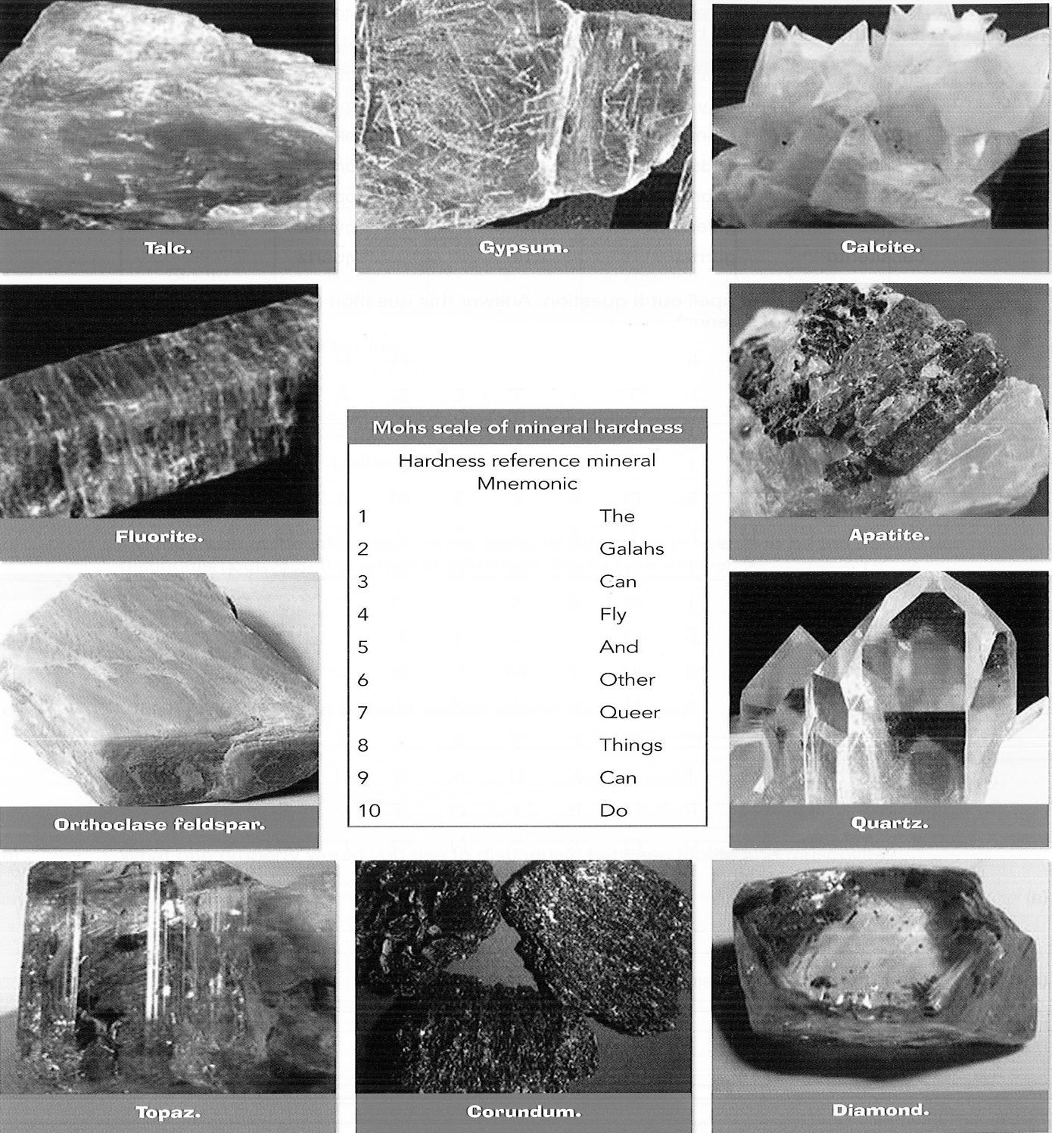

- The wonder word contains the names of these minerals arranged either horizontally or vertically and either forwards or backwards but not diagonally.

amethyst | chalcopyrites | gold | magnetite | ruby
apatite | clay | gypsum | mica | rutile
asbestos | diamond | haematite | olivine | sphalerite
azurite | feldspar | galite | onyx | talc
bauxite | fluorite | jade | opal | topaz
calcite | Galena | jasper | pyrites
cassiterite | garnet | lime | quartz

The letters left over spell out a question. Answer this question (you may have to use your library or a dictionary of science).

- The question.

_______________________________________________________________________

- Your answer to the question.

____________________________________________________________________________________________________________________________________________________________________________________________________________________

- Use the clues and the grid below to solve the logical thinking puzzle. Read each clue and then put a cross in the appropriate square in the grid if the clue tells you something negative, or a tick if the clue identifies one of the minerals for you.

For example, the first clue says that mineral F is harder than five other minerals, so the hardness of minerals F must be 6. Therefore put a “tick” in cell F6 and `’crosses’ in all other cells in row hardness 6 and put crosses in every other cell in the F column (done for you).

Logical thinking puzzle

Eight minerals, in order of softness (1) to hardest (8) are talc, gypsum, calcite, biotite, fluorite, feldspar, quartz and diamond. (Note that these are not the Mohs scale of hardness figures, just numbers used for this exercise.)

Samples of them are labelled A, B, C, D, E, F, G and H but not in that order. Use the clues and the grid to identify which sample is which mineral.

Clues

Mineral F will scratch five of the others D will scratch C and E, but not G.

A is softer than B and E. C is not fluorite.

C is harder than H, but softer than F. F will scratch E.

H is not the softest mineral. E is harder than C.

B can be scratched by only five of the other minerals.

 | The minerals
Hardness of mineral | A | B | C | D | E | F | G | H
1 |  |  |  |  |  | x
2 |  |  |  |  |  | x
3 |  |  |  |  |  | x
4 |  |  |  |  |  | x
5 |  |  |  |  |  | x
6 | x | x | x | x | x |  | x | x
7 |  |  |  |  |  | x
8 |  |  |  |  |  | x

2. How rocks are formed

Read the passage below, then answer the questions that follow.
Rocks are classified by firstly considering how they were formed. On this basis, all rocks fall into three categories: igneous, metamorphic and sedimentary.

Igneous rocks are those which have solidified from molten material either on top of the Earth’s surface or beneath it. Igneous rocks which form on top of the surface are called volcanic igneous rocks, while those which solidify under the surface are known as plutonic igneous rocks. The minerals in volcanic rocks have smaller crystals in them than those in plutonic rocks because they cool down faster and the crystals do not have time to grow.

Metamorphic rocks form when other rocks (igneous, sedimentary or other metamorphic rocks) are changed by intense heat and/or pressure. Heat deep within the Earth’s crust can recrystallise minerals in the rocks, while high pressure crushes and deforms the crystals.

Sedimentary rocks form from sediment. Sediments are small particles from other rocks which are weathered and eroded by flowing water, wind and ice. Sediments are carried to lakes or oceans whee they settle to the bottom.

As sediments accumulate, different layers are formed (the main feature of most sedimentary rocks). Pressure from successive layers slowly presses the particles in the bottom layers close together. Chemicals dissolved in the water crystallise in the spaces between the sediment particles, cementing them together to form rock layers.

Use the information above to complete the following classification diagram.

2 A. Igneous rocks

- Read the passage below, then answer the questions that follow.

Igneous rocks make up about 80% of the earth’s crust. They are formed from molten rock, or magma, which is underneath the solid crust.

There are two main types of igneous rocks. Volcanic or extrusive rocks are formed when magma forces its way through cracks or faults on the Earth’s crust and flows onto the surface. Sometimes a volcano is formed as the magma, now known as lava, flows onto the surface. Most lava cools and solidifies to form basalt, a dark blue rock often used in buildings for feature walls and as `blue metal’ in road base. Igneous rocks are formed when magma solidifies in between other rock layers and forms a sill. When the magma solidifies in rocks that cut across rock layers dykes are formed.

Another volcanic rock is pumice which forms from lava which contains lots of gases. Pumice is usually thrown out during a volcanic explosion and the rock solidifies before all the holes formed as the gases escape from the lava disappear. Pumice is a very light, `frothy’ rocks which floats on water. Obsidian, also known as volcanic glass, cools so quickly that it has no crystals. Volcanic tuff is formed as volcanic ash and particles exploded from a volcano settle and harden in a similar process to the formation of sedimentary rocks.

Plutonic, or intrusive rocks, are formed when magma solidifies underneath the Earth’s surface. The most common rock formed this way is granite, used in buildings for bench tops and paving. Granite usually forms from a huge mass of magma forming a batholith. Granite comes in a wide variety of colours and crystal sizes depending on the minerals in it and how slowly it cools. Other plutonic rocks include diorite, gabbro and dolerite. In general, all plutonic rocks have larger crystals than volcanic rocks because magma cools more slowly than lava.

Sedimentary rocks can also be formed from the remains of plants and animals that live in oceans. The main sedimentary rock formed this way is limestone.

Sedimentary rocks have two other main differences from other types of rocks. They usually form in horizontal layers, often referred to as strata, and they often contain fossils. Fossils are the remains of, or evidence of the remains of plants and animals from past ages.

- Complete the table.

Noun | Adjective | Verb
Solid
 |  | Intrude
 | Extrusive
Crystal
 |  | Melt

- Complete the diagram to summarise the classification of igneous rocks from the passage.

- Volcanic and plutonic rocks can be easily distinguished from each other just by looking at them, even if you do not know what the rock actually is.

- How can they be distinguished? _______________________________________
_________________________________________________________________

- Why do they have this difference? ______________________________________
_________________________________________________________________

- Below the crossword blanks are all the igneous jumbled terms that fit into it. Unjumble them then fit them into the blanks. One letter has been given as a clue.

2 C. Sedimentary rocks

- Read the passage below, then answer the questions that follow.

Worn away fragments of rock carried by running water, wind or ice (the three agents of erosion) are called sediments. Sediments can range in size from small clay particles, to sand, to giant boulders as big as a house.

Sedimentary particles are deposited in lakes, rivers, seas and oceans, along glacier beds and in the desert. They pile up over a long period of time and harden to form sedimentary rocks. Sedimentary rocks consist of these weathered particles cemented together by various soil chemicals. Sedimentary rocks make up about 5% of the Earth’s surface.

Sedimentary rocks are classified partly on the basis of the size of the particles which make them up. The smallest sediments, clay or silt, harden to form the rock called claystone or siltstone. A rock which is composed of all sand-sized sediment cemented together is called sandstone. A rock containing a mixture of clay and sand-sized particles is called shale.

Conglomerate consists of varying sized rounded sedimentary particles cemented together. The sediments in a conglomerate might range from the size of sand to pieces of other rocks the size of your fist or even larger. If the particles are angular in shape, the rock is called a breccia.

Sedimentary rocks can also be formed from the remains of plants and animals that live in oceans. The main sedimentary rock formed this way is limestone.

Sedimentary rocks have two other main differences from other types of rocks. They usually form in horizontal layers, often referred to as strata, and they often contain fossils. Fossils are the remains of, or evidence of the remains of plants and animals from past ages.

The table below shows the composition of some common sedimentary rocks. The diagram shows a magnified view of four sedimentary rocks.

Use the information in the table to identify each rock.

Rock A = __________________________________________________________________
Rock B = __________________________________________________________________
Rock C = __________________________________________________________________
Rock D = __________________________________________________________________

2 D Fossils

The word fossil comes from the Latin word fossilis, meaning`dug up’. Fossils are the remains of animals and plants from the past – or any other evidence of past life, like footprints preserved in rocks or tree sap (amber) or ice.

The formation of igneous and metamorphic rocks involves a great deal of heat and pressure, so plant or animal remains caught up in them would be burnt and crushed beyond recognition. Most fossils are found in sedimentary rocks, and most commonly in those formed under the sea.

The soft, fleshy parts of plants and animals will decay more quickly than the hard parts. Shells, skeletons, teeth, branches and twigs are found preserved much more often than flowers and tissues, although, every now and then, entire organisms are found. Some insect fossil remains have been found in amber. In such cases, the insects got stuck in the resin of a tree about 40 million years ago. Since then the resin hardened to amber.

ACTIVITY: The sentences below describe how fossils form.
The pictures illustrate each step in this process. Your task is to put the sentences in the correct order, and then to copy the picture and match the pictures to the correct sentence.

Sentence A: Sediment around the shell hardens to form rock. The shell may remain in the rock, or dissolve leaving only a mould, or the mould might fill with minerals seeping through the rock to form a cast.

Sentence B: Eventually erosion might wear away the rock and expose the fossil, or it might be exposed as the rock is quarried for use.

Sentence C: This burial stops the creature’s body from being eaten, and broken up by scavengers. The soft parts will still probably rot away, but the hard skeleton or shell will remain.

Sentence D: Over millions of years, the sea level might fall, or mountains build up, as the rocks fault and fold and get pushed up by crustal movements. Our fossilised shell might end up in rock thousands of metres above the seabed.

Sentence E: When a sea creature dies, its body sinks to the bottom. If strong currents exist, it will be swept around and broken up. However, if there is no current, it will become buried by sediment or other bodies.

Correct order of sentences | The way fossils form (copy the sentences into here) | Pictures to illustrate the process

Inferences from fossils

Fossils are important because they give us clues about how life looked and lived in past ages: they tell a story about the history of the Earth. They can give us a time sequence of events, tell us about the climate of the area in the past, and give us evidence of how life forms have changed over time.

Look at each of the photographs or diagrams below and see if you can see the
story they tell.

- What do you think each of these animals ate, and why do you think this?.

_______________________________________________________________________________________________________________________________________________________________________________________________________________________________________________________________________________________________________________________________________________________________________________________________________________________________________________________________________________________________________________________________________________________________________________________________________________________________________________________________________________________________________________________________________________________________________________________

- What story do these fossil tracks tell?

______________________________________________________________________________________________________________________________________________________________________________________________________________________________________________________________________________________________________________________________________________________________________________________________________________________________________________________________________________

- Suggest the living environment of these fossils. Justify your answer.

_______________________________________________________________________________________________________________________________________________________________________________________________________________________________________________________________________________________________________________________________________________________________________________________________________________________________________________________________________________________________________________________________________________________________________________________________________________________________________________________________________________________________________________________________________________________________________________________
Inferences from rock layers
One of the reasons why geologists like maps of roadside cuttings are lists of fossils in rocks is that they can use them to reconstruct the geological history of an area. The sequence of the rocks tells them the order of events in the past, and the fossils can be radiometrically dated (using the radioactivity of isotopes of elements they contain) to tell them when each event occurred.

The law of superposition

It may seem obvious but the law of superposition is essential to any understanding of geological history. It states: In a sequence of undisturbed rocks, the oldest rocks are on the bottom and the youngest are on the top.

Applying this law has some problems though. It only works if the rock layers have not been overturned by massive, mountain-building movements in the crust, or folded extensively by crustal pressures.

If we think there is a problem, we need to look at the layers more closely. For example, the sequence of fossils may tell us that one sequence is upside down. The size of the rock particles in the layers could show this as well.

The law of cross-cutting relationships

Not all rocks form in layers. Sometimes igneous rocks intrude rock layers, forcing their way into cracks while still molten. To cover this situation, we have the law of cross-cutting relationships. It states: Igneous rocks that intrude other rocks are younger than the rocks they intrude.

- Use the law of superposition and the law of cross-cutting relationships to list the rocks in the diagram below in order from oldest to youngest.

________________________________________________________________________________________________________________________________________________________________________________________________________________________________________________________________________________________________________________

- A geologist drew a diagram of the rocks she saw in a series of roadside cuttings along a short section of a new highway cut through three adjacent hills as shown below. On the diagram she also showed the main fossils in each rock layer.

- Which rock do you think is the oldest? Why?
_______________________________________________________________________
- Why are the rock layers sloping in different directions?
_______________________________________________________________________
- Why is there no pink or red rock in cutting B or C?
_______________________________________________________________________
- Why is there no orange rock in cutting B?
_______________________________________________________________________
- Which died first: the fern (pink layer) or the fish (green layer)? Explain.
_______________________________________________________________________
_______________________________________________________________________

7. Metamorphic rocks

- Read the passage below, then answer the questions that follow.

The Earth’s crust is constantly moving. Deep inside the Earth it is very hot. This heat and the forces which accompany Earth movements can change rocks. They melt and recrystallise or they are squeezed and deformed. Rocks which are changed like this are called metamorphic rocks.

Marble is a metamorphic rock. It is formed when the sedimentary rock, limestone, is partly melted and recrystallised. Marble comes in many colours, often with misty bands of other colours through it. Pure white marble from Carrara in Italy is highly valued for use in carvings, tabletops and vases.

Metamorphic rocks are made either by contact metamorphism or by regional metamorphism.
Contact metamorphism occurs when molten magma is forced into cracks in rocks in the crust. The heat from the magma can recrystallise the rocks it intrudes. Sandstone can be changed into quartzite in this way.

Regional metamorphism takes place over a much larger area. It occurs during movements in the crust of the Earth. In regional metamorphism, rocks are changed by both heat and the strong forces in the crust.

Granite, an igneous rock changes to the metamorphic rock gneiss when it is subjected to high pressures which deform the mineral crystals. The metamorphic rock slate, formed from metamorphism of shale can be further metamorphosed into schist in the same way

- Rewrite the jumbled sentences in the spaces below.

- Rocks other formed are rocks are metamorphic when changed.
_________________________________________________________________

- Changed crust under pressure and rocks Earth’s heat the are by.
_________________________________________________________________

- Cracks intrudes rock into molten changes touches it and the rocks.
_________________________________________________________________

- Recrystallised formed is limestone when is marble.
_________________________________________________________________

- Used metamorphic rocks is marble one commonly rocks of the most.
_________________________________________________________________

- Metamorphism quartzite when changed is by formed is sandstone.
_________________________________________________________________

- Forms contact there metamorphism are two regional and of.
_________________________________________________________________

- Houses is slate roofs used on the of.
_________________________________________________________________

- Complete the table.

Original Rock | Type of original rock | Metamorphic rock formed from this
Limestone
Sandstone
Granite
Shale
Slate

7.2.1. The rock cycle

If we accept that the Earth formed as a ball of molten material thrown off from the Sun, all the material of the Earth would have originally been molten. The first rocks to form would have been igneous rocks, formed as the surface of this molten ball cooled.

With cooling came condensation of gases in the atmosphere, rain and acid and acid rain. The first sediments, resulting from the weathering and erosion of the igneous rocks, gradually formed. These would have compacted over time to form the first sedimentary rocks.

While this was happening, heat from under the crust and violent igneous activity may well have formed the first thermal metamorphic rocks, either from the igneous rocks or the new sediments.

The Earth is estimated to be 4500 million years old so these processes have been occurring for a long time. We might expect, with 4500 million years of erosion that the surface would be worn flat by now, and all the sediment carried into the oceans.

However, there are other forces in play. Molten material pushes up into and through cracks; crustal blocks push and grind against each other, continually adding to mountain ranges; and as mountains wear away, new rock pushes up from the bottom. There is a continual cycle of production, change and weathering of rocks occurring on top of and under the surface of the Earth – the rock cycle.

During the formation of rocks, five main processes act on the materials from which the various rocks are formed, as shown in the diagram below.

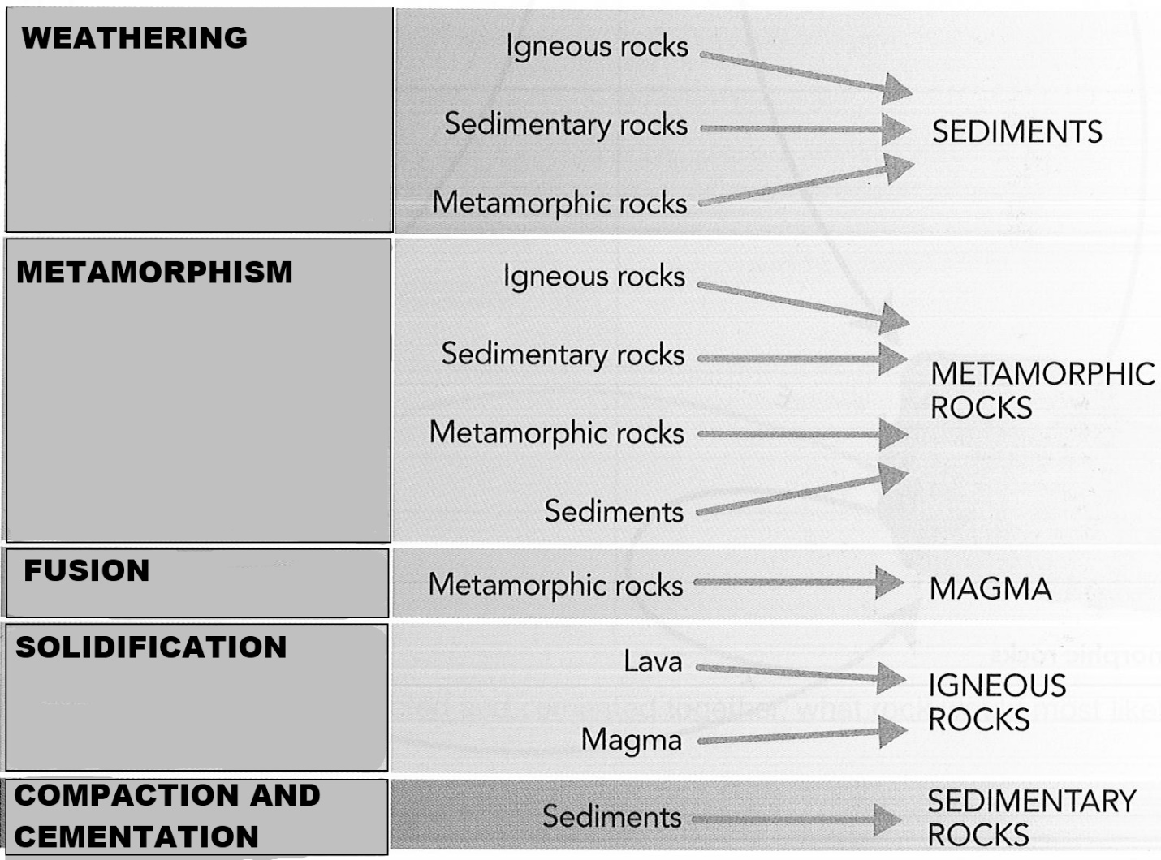

7.2.1.1 The diagram below shows a simple rock cycle.
Your task, with your friends, is to discuss where the following labels go (print them neatly inside the arrows), and then add them to the cycle to complete it. Note that each label will need to be used more than once.

Label 1 Weathering, erosion deposition, compaction
Label 2 Melting then cooling
Label 3 High temperature and pressure

7.2.1.2 What difference is there in igneous rocks that cool slowly compared to those
that cool quickly?

___________________________________________________________________________________________________________________________________________________________________________________________________

7.2.1.3 What are the two main agents of metamorphism?

_________________________________________________________________

7.2.1.4 What is the difference between weathering and erosion?

___________________________________________________________________________________________________________________________________________________________________________________________________

7.2.1.5 What would have been the first rocks on Earth? Justify your answer.

___________________________________________________________________________________________________________________________________________________________________________________________________

7.2.1.6 Complete the table below.

Processes which act on the materials from which rocks are formed | What this process does to the material

7.2.1.7 If beach sand was compacted and cemented together, what rock would most
likely be formed?

_________________________________________________________________

7.2.2 Recognising sedimentary rocks

Recognising rocks is not easy. Even if you know all the characteristics of rocks, it still takes lots of practice and experience to tell some of them from others.

Some are obvious, like conglomerate and breccia with their different sized rounded or angular fragments cemented together, but others, like shale, sandstone and mudstone can sometimes look almost the same if you don’t have an expert eye.

7.2.2.1 In this activity you will ideally have a real sample of each rock to look at as well
as the photographs on the next page. You should also have a magnifying glass.

Your task is to describe the properties of each rock – things that will help you recognise other samples of these rocks later. You could also compare the properties with some of the others.

For example, you might describe both sandstone and shale as `gritty’ feeling, but comment that the sandstone is `more gritty’ than the shale (because shale’s sediment particles are smaller).

Do this activity with your friends to share ideas and to get other input into your descriptions.

Write your descriptions in the spaces on the next page.

Conglomerate

_____________________________________________________________________________________________________________________________________________________________________________________________________________

Breccia

_____________________________________________________________________________________________________________________________________________________________________________________________________________

Sandstone

_____________________________________________________________________________________________________________________________________________________________________________________________________________

Shale

_____________________________________________________________________________________________________________________________________________________________________________________________________________

Limestone
_____________________________________________________________________________________________________________________________________________________________________________________________________________
7.2.6 Recognising igneous rocks
Granite, like many other rocks, comes in many colours

Igneous rocks are relatively easy to distinguish from sedimentary rocks (they are crystalline and not gritty) but not so easy to tell one from some metamorphic rocks. So again, experience plays a big part in being able to identify them.

7.2.6.1 Research the types of rocks that underlie
the area in which you live.

___________________________________________________________________________________________________________________________________________________________________________________________________________________________________________________________________________________________________________________________________________________________________________________________________________________________________________________________________________________________________________________________________________________________________________________________________________

7.2.6.2 In this activity you will ideally have a
Real sample of each rock to look at as well as the photographs on the next page. You should also have a magnifying glass.

Your task is to describe the properties of each rock – things that will help you recognise other samples of these rocks later. You could also compare the properties with some of the others.

For example, you might describe both granite and dolerite as crystalline, but comment that the granite has larger crystals than the dolerite because it cooled more slowly.

Do this activity with your friends to share ideas and to get other input into your descriptions. Write your descriptions in the spaces on the next page.

Granite

____________________________________________________________________________________________________________________________________________________________________

Pumice

____________________________________________________________________________________________________________________________________________________________________

Basalt

____________________________________________________________________________________________________________________________________________________________________

Dolerite

____________________________________________________________________________________________________________________________________________________________________

Obsidian
____________________________________________________________________________________________________________________________________________________________________

Tuff
____________________________________________________________________________________________________________________________________________________________________

7.2.7 Recognising igneous rocks

Metamorphic rocks are similar to igneous rocks. So again, experience plays a big part in being able to identify them.

7.2.7.1 In this activity, you will ideally have a real sample of each rock to look at as well
as the photographs on the next page. A magnifying glass will also be useful.

Your task is to describe the properties of each rock – things that will help you recognise other samples of these rocks later. You could also compare the properties with some of the others.

For example, you might describe both gneiss and schist as crystalline and foliated (wavy) but comments that the crystals in the schist are smaller and more deformed than those in the gneiss (because of the second metamorphism the rock has undergone).

Do this activity with your friends to share ideas and to get other input into your descriptions. Write your descriptions in the spaces on the next page.

_______________________________________________________________________________________________________________________________________________________________________________________________________________________________________________________________________________________________________________________________________________________________________________________________________________________________________________________________________________________________________________________________________________________________________________________________________________________________________________________________________________________________________________________________________________________________________________________

Gneiss

____________________________________________________________________________________________________________________________________________________________________

Gabbro

____________________________________________________________________________________________________________________________________________________________________

Marble

____________________________________________________________________________________________________________________________________________________________________

Schist

____________________________________________________________________________________________________________________________________________________________________

Quartzite
____________________________________________________________________________________________________________________________________________________________________

Slate
____________________________________________________________________________________________________________________________________________________________________
7.2.8 Structures and landforms

7.2.8.1 Weathering. Followed by the erosion of the weathered fragments results in many
spectacular landforms, some of which are pictured below. Your task is to choose any four landforms and describe what they are and how they form.

_______________________________________________________________________________________________________________________________________________________________________________________________________________________________________________________________________________________________________________________________________________________________________________________________________________________________________________________________________________________________________________________________________________________________________________________________________________________________________________________________________________________________________________________________________________________________________________________

Chapter 7 Test

- Clarify the concept of igneous rocks.

____________________________________________________________________________

- Clarify the concept of metamorphic rocks.

____________________________________________________________________________

- Clarify the concept of sedimentary rocks.

____________________________________________________________________________

- Compare plutonic and volcanic igneous rocks.

________________________________________________________________________________________________________________________________________________________

- Compare intrusive and extrusive igneous rocks.

________________________________________________________________________________________________________________________________________________________

- If you knew you were holding a plutonic igneous rock in one hand and a volcanic igneous rock in the other, how, with a single glance, could you tell which was which?

_______________________________________________________________________

- Explain why they have this difference.

_______________________________________________________________________

- What happens to the crystals of particles in rocks when they undergo metamorphism?

____________________________________________________________________________

- Complete the table to give five examples of each type of rock.

Igneous rocks | Sedimentary rocks | Metamorphic rocks
(i)
(ii)
(iii)
(iv)
(v)

How much to you remember or already know?

- What is a rock?
- What are the three types of rocks?
- Name one rock from each of these three types of rocks.
- Which rocks are formed when weathered particles are compacted and cemented together?
- Which rocks form when molten material solidifies?
- Which rocks form when other rocks are changed by heat /and/or pressure?
- What rock is formed when sandstone is changed by heat and pressure?
- List five uses for rocks.
- What is weathering?
- What is erosion?
- What are continental plates?
- What happens along the boundaries where continental plates meet?
- What is friction?
- What does friction produce?
- What is an ore?
- What chemical element is diamond composed of?
- What is the symbol for this element?
- Where would you find this element on the periodic table?
- Name another form of this element.
- What gas is formed when this element burns in air?
- Under what conditions will large mineral crystals form?
- What is a chemical process?
- What is a physical process?
- Which one of these processes forms new substances?
- What is a compression force?
- What is the name of the molten material flowing from a volcano?
- What does this molten material harden to form?
- What is the name for molten material still under the ground?
- What is a volcanic rock?
- What is a plutonic rock?

Use the following information to answer the next two questions.

The diagram represents a section of the Earth’s crust which has been broken by several faults.

- Which choice correctly identifies the three faults?

 | A | B | C | D
F₁ | Normal | Reverse | Normal | Reverse
F₂ | Reverse | Normal | Normal | Reverse
F₃ | Reverse | Reverse | Reverse | Normal

- Which crustal block(s) have moved downwards relative to the others?
- Q only
- P and R only
- P and Q only
- D only

- The bar chart shows the minerals in an ore.

What proportion of the ore is mineral X
- 25%
- 30%
- 35%
- 40%

- What is the non-useful material in an ore called?
- Gangue
- Non-economic
- Non-metallic
- Waste

